AFTER A 30 YEAR CAREER, FORMER FBI COMMUNITY
OUTREACH COORDINATOR RICK BERGER IS TAKING
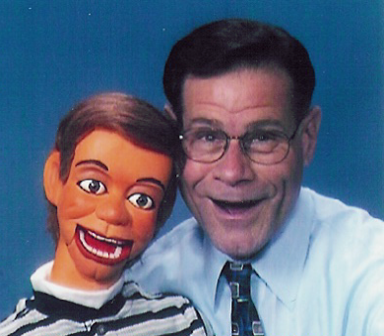
HIS SHOW ON THE ROAD!
"Who, Me?"

“Who Me?” is a substance abuse prevention, safety and self-esteem
program using ventriloquism.

Children today are continually bombarded with temptation and
challenged with choices – choices that can dramatically change
their lives. If they are to make the right choices, they need
knowledge and guidance.

With help from his “friends,” Rick explores the topics of drugs,
personal safety, and self-esteem, all in terms that are age
appropriate and easy for kids to understand. Interaction takes place
not only between Rick and his friends, but with the children as well.
The program is entertaining as well as informative.

Music is an integral part of the show, as the songs echo the message.
Rick and his friends sing about drugs and safety to melodies that kids
recognize.

Grade appropriate follow-up lessons are provided so that the
program’s message can be reinforced in the classroom.

For information and to book this program, contact
Rick Berger, PO Box 6207, Parsippany, NJ 07054
Phone and fax: (973) 331-9630
e-mail: ventevents@hotmail.com

